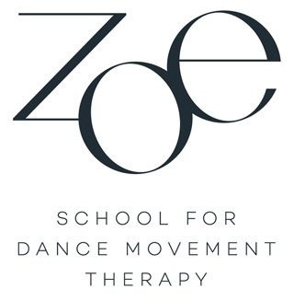

Newsletter October/November 2021

Spirituality in Dance Movement Therapy

I am often asked what place spirituality has in the course of ZOE SCHOOL FOR DANCE MOVEMENT THERPY. This is a very good and also important question. First a statement from me personally: Spirituality is resident as a vibration in each of our cells, so it is deeply rooted in our being. In this newsletter I would like to speak primarily of spiritual attitude and spiritual experience.

From my point of view spirituality does not know any dualization e.g. of body and mind/spirituality: a spiritual attitude overcomes this and knows neither judgements nor condemnations. This spiritual attitude promotes the deep experience and insight into things in themselves or the experiential knowledge of the essence of things. From this flows the experience of "more than what our external senses can grasp." This awakens intuition and inner wisdom and leads into the absolute presence of all that is.

In the ZOE SCHOOL you learn to observe your movement and subsequently the movement of your clientele as pure movement, to perceive it and to grasp it without judgement or condemnation. As you become familiar with this during the course, you will automatically approach the essence of experience and the "more than what our outer senses can grasp", which corresponds to a spiritual attitude. We also call this "the therapeutic intuition".

Here is another way of looking at the connection between dance therapy and spirituality: The body basically knows no duality. It expresses what is, whether pleasant, unpleasant, desired or undesired. "Pleasant", "unpleasant", "desired" or "undesired" originates from our dualizing interpretation. With each so-called negative interpretation we increasingly distance ourselves from our (body) experience, split off, create our shadows and dualize, which can lead to physical and psychological disorders.

We dance therapists therefore strive in the therapy process to dissolve this dualization by accompanying our clients on their way into the presentness of the body, of life and experience and thus into their vitality. Doesn't this sound like a growth process of mystics and sages or of really spiritual people?

To this end, I would like to quote a poem by Marion Woodman from her book, Coming Home to Myself:

"We can swing back and forth
Between opposites indefinitely
Better to stand
On the stillpoint
At the center where all is pure motion, pure live and fulfillment in spirit."

Both the dance therapist Anna Halprin and all the dance therapists who have developed the Authentic Movement method, also part of our curriculum, for many years, convey to us the depth of experienced movement. They have all encountered spiritual experience along the way and have found that this is the real path of healing.
So, in the course you are going on a journey that puts great emphasis on the spiritual attitude on the basis of academic-oriented knowledge. ZOE SCHOOL is also breaking new and significant ground in this regard.

